Course code: CSA1013 Name: S Jeena Princy
Course: Software Engineering Reg No.: 192572058

CO 1 ASSESSMENT TOOL- 1

AI-Driven Smart Urban Noise Pollution Monitoring and Mitigation System

Abstract
Urbanization and industrial growth have significantly increased noise pollution in cities, affecting the health, productivity, and quality of life of citizens. Traditional methods of monitoring noise pollution mainly rely on manual inspections and periodic measurements, making it difficult to identify real-time noise hotspots and take immediate corrective actions. This project proposes an AI-Driven Smart Urban Noise Pollution Monitoring and Mitigation System that continuously collects environmental noise data using IoT-based sound sensors installed at various locations. The collected data is transmitted to a cloud platform, where Artificial Intelligence algorithms analyze noise patterns, identify abnormal noise levels, predict future noise trends, and generate real-time alerts whenever permissible noise limits are exceeded.
1. Problem Understanding
Urban noise pollution has become increasingly difficult to manage because traditional monitoring systems fail to capture continuous variations in environmental noise. Manual inspections are performed only at selected intervals, making it impossible to identify temporary noise spikes, recurring hotspots, or emergency situations.
Several challenges exist in the current monitoring process:
- Lack of continuous monitoring across urban areas.
- High dependency on manual inspections and physical measurements.
- Delayed identification of excessive noise levels.
- Absence of predictive analysis for future noise patterns.
- Limited visualization of noise pollution hotspots.
- Difficulty in taking immediate corrective actions.
- Inefficient generation of environmental compliance reports.
- Poor public awareness regarding environmental noise exposure.
These challenges reduce the effectiveness of environmental management and make urban planning more difficult.
Problem Statement:
Existing urban noise monitoring systems depend mainly on periodic manual measurements, which are unable to provide continuous observation of environmental noise. As a result, authorities often fail to detect temporary noise spikes, identify recurring noise hotspots, and implement timely mitigation strategies.
There is a need for an intelligent monitoring system capable of continuously collecting environmental noise data, analyzing noise patterns using Artificial Intelligence, identifying noise hotspots through Geographic Information Systems (GIS), predicting future noise trends, and automatically generating alerts whenever permissible noise limits are exceeded. Such a system will support evidence-based policymaking, improve environmental monitoring, and enhance the quality of urban life.
Need for the Project:
The increasing population and rapid urbanization have significantly increased environmental noise levels in modern cities. Smart city initiatives require intelligent environmental monitoring systems capable of providing accurate, continuous, and real-time information.
The proposed project is needed because it:
- Enables continuous monitoring of urban noise levels.
- Reduces dependence on manual inspections.
- Provides real-time alerts during excessive noise conditions.
- Identifies noise pollution hotspots using GIS mapping.
- Predicts future noise trends using Artificial Intelligence.
- Supports government agencies in environmental policy implementation.
- Improves public health and environmental sustainability.
- Assists urban planners in making informed development decisions.
2. Stakeholder Analysis
A stakeholder is any individual, organization, or authority that is directly or indirectly affected by the proposed system. The success of the AI-Driven Smart Urban Noise Pollution Monitoring and Mitigation System depends on effective collaboration among all stakeholders.
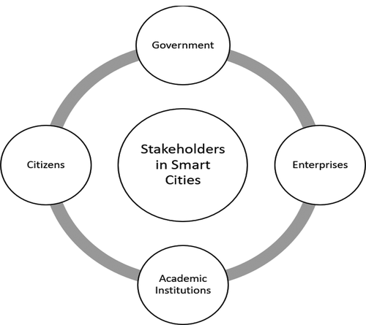

1.Municipal Corporation
The Municipal Corporation is responsible for monitoring environmental quality and implementing noise control measures. It uses the system to identify high-noise zones, enforce regulations, and plan mitigation strategies.
Role:
- Monitor city-wide noise levels.
- Take corrective actions.
- Implement noise control policies.
2.Pollution Control Board
The Pollution Control Board ensures industries, commercial areas, and public spaces comply with environmental noise standards. The system helps generate compliance reports and supports legal enforcement.
Role:
- Monitor environmental compliance.
- Analyze pollution reports.
- Take legal action against violations.
3. Citizens
Citizens are the primary beneficiaries of the system. They receive timely information about excessive noise levels and benefit from a healthier living environment.
Role:
- Receive environmental alerts.
- Report unusual noise incidents.
- Support community awareness.
4. Industries and Commercial Establishments
Industries and commercial organizations generate significant environmental noise. The system helps them monitor their noise emissions and comply with government regulations.
Role:
- Monitor operational noise.
- Maintain environmental compliance.
- Reduce unnecessary noise generation.
5. Hospitals and Educational Institutions
Hospitals and schools require quiet surroundings for patient recovery and effective learning. The proposed system helps identify nearby noise hotspots and supports authorities in implementing protective measures.
Role:
- Monitor surrounding noise levels.
- Request mitigation measures.
- Improve environmental safety.
6. Traffic Police and Transport Authorities
Traffic congestion is one of the major contributors to urban noise pollution. Traffic authorities use the system to identify noisy traffic corridors and improve traffic management.
Role:
- Monitor traffic-related noise.
- Reduce congestion.
- Implement better traffic control strategies.
7. Smart City Administration
Smart City authorities integrate the collected data into city management systems to support sustainable urban planning and intelligent governance.
Role:
- Analyze environmental data.
- Improve city planning.
- Support smart governance initiatives.
6. Challenge Analysis
Although modern cities have adopted environmental monitoring practices, several challenges still exist in managing urban noise pollution effectively.
Challenge 1: Lack of Continuous Monitoring
Traditional monitoring methods collect noise data only during scheduled inspections, making it difficult to detect sudden increases in noise levels.
Challenge 2: Delayed Response
Authorities often receive information long after excessive noise has occurred, reducing the effectiveness of corrective actions.
Challenge 3: Manual Data Collection
Manual measurements require significant manpower, equipment, and operational costs, making large-scale monitoring inefficient.
Challenge 4: Absence of Predictive Analytics
Existing systems focus only on current measurements and cannot predict future noise patterns or identify emerging hotspots.
Challenge 5: Poor Visualization
Traditional reports provide limited geographical representation of noise pollution, making it difficult for authorities to identify affected regions quickly.
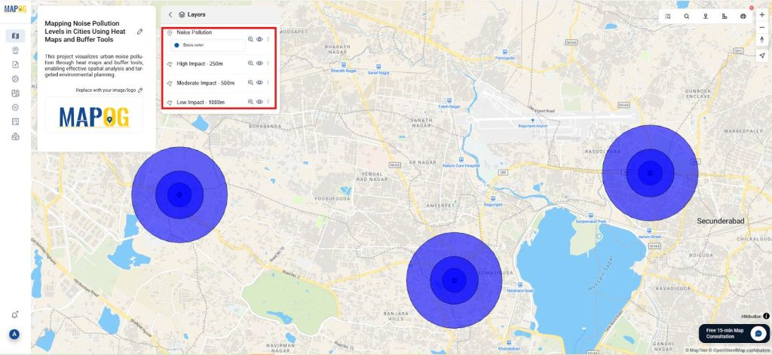
Challenge 6: Limited Public Awareness Citizens often remain unaware of harmful environmental noise levels.
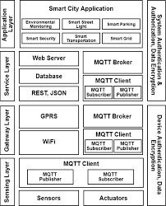
7. Current System Analysis

Currently, noise pollution monitoring in most cities is performed using manual inspections and portable sound level meters. Environmental officers visit selected locations, record the noise levels, and prepare reports for further analysis. Although this method provides accurate readings at the time of measurement, it does not support continuous monitoring or real-time decision-making. Due to limited manpower and equipment, only a few locations can be monitored regularly, making it difficult to detect sudden increases in noise pollution.
8. Existing System
The existing system mainly consists of sound level meters operated manually by environmental authorities. Measurements are collected periodically and stored in reports for later analysis. Some urban areas also use fixed monitoring stations, but these systems are expensive and cover only limited locations. They generally do not provide intelligent analysis, prediction, or automatic alerts.
Advantages of the Existing System
- Simple and easy to operate.
- Provides accurate noise measurements during inspection.
- Supports environmental compliance reporting.
- Requires minimal software infrastructure.
Disadvantages of the Existing System
- No real-time monitoring.
- High dependency on manual inspections.
- Limited geographical coverage.
- No AI-based prediction of future noise levels.
- Delayed reporting and response.
- High operational and maintenance costs.
- Difficult to identify temporary noise hotspots.
Software Engineering Principles Used
The proposed system follows key Software Engineering principles to ensure that it is efficient, reliable, and easy to maintain.
1. Modularity
The system is divided into independent modules such as Data Collection, AI Analysis, Alert Management, GIS Visualization, User Management, and Report Generation. Each module performs a specific task, making development and maintenance easier.
2. Scalability
The system can be expanded by adding more IoT sensors across different locations without requiring major software modifications. This allows the system to support growing smart cities.
3. Maintainability
The modular design allows developers to update or improve individual components without affecting the entire system. This reduces maintenance time and cost.
4. Reliability
The system continuously collects and processes environmental data, ensuring accurate monitoring even during long-term operation. Cloud storage also minimizes the risk of data loss.
5. Security
Data transmitted from IoT devices to the cloud is protected using secure communication protocols. User authentication ensures that only authorized personnel can access sensitive environmental information.
6. Usability
The dashboard provides a simple and user-friendly interface with graphs, heatmaps, and real-time alerts, enabling officials to understand environmental conditions quickly.
7. Efficiency
AI algorithms automatically process large amounts of sensor data, reducing manual effort and improving decision-making speed.
Methodology & Framework Justification
The project follows the Agile Software Development Life Cycle (SDLC) because it supports iterative development, continuous testing, and regular improvements based on user feedback. Agile enables faster development and allows new features to be added easily during different project phases.
Phases of Agile SDLC
- Requirement Analysis
- System Design
- Development
- Testing
- Deployment
- Maintenance
Framework Justification
The Agile methodology is chosen because it:
- Provides flexibility during development.
- Supports continuous improvement.
- Reduces development risks.
- Delivers faster software updates.
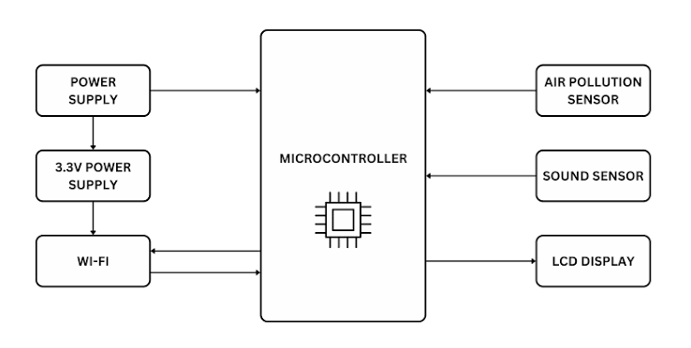
- Enhances collaboration among team members.
Expected Outcomes
The proposed AI-Driven Smart Urban Noise Pollution Monitoring and Mitigation System is expected to:
- Continuously monitor urban noise levels in real time.
- Detect high-noise areas accurately.
- Generate instant alerts when noise exceeds permissible limits.
- Assist authorities in making quick decisions.
- Improve environmental monitoring and public health.
- Support smart city initiatives through intelligent data analysis.
Limitations
Although the proposed system offers several advantages, it has a few limitations:
- High initial installation cost for IoT sensors.
- Requires a stable internet connection for real-time data transmission.
- AI predictions depend on the quality and quantity of collected data.
- Periodic maintenance of sensors is required.
- System performance may be affected by hardware failures or network interruptions.

